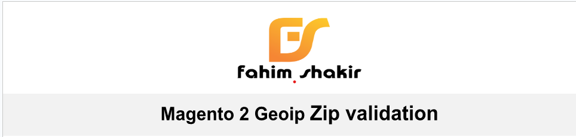

**User Guide**

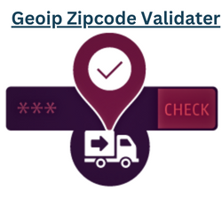

Zipcode Based COD Pro extension allows admins to configure a zipcode-based cash delivery method so that it will only display to specific postcodes/zipcodes. The plugin extends the standard COD payment method to be like a location-based cash-on-delivery method where a merchant can add/update thousands of zipcodes using our CSV upload feature which reduces many hours of stress. The cash-on-delivery extra fee option allows admins to configure additional COD fees only for COD orders. Additionally, admins can configure separate cash on delivery.

**Features**

* It allows the users to know about the shipping availability on the product page.
* The admin can add, edit, view, and delete multiple regions.
* The admin can select multiple available regions for a product.
* Available Regions can be assigned to both new and existing products.
* Every zip code and region has a unique Id assigned to it for better management.
* Region Status can be enabled or disabled by the admin.
* Zip codes can be updated and deleted by the admin.
* The filter option can be used to search for any specific region or zip code.
* Shipping Availability Check supports multiple languages and translations.
* The registered user's saved address automatically appears in the zip code field.
* The recent history of the zip code search for a product can also be seen by the users.

**Download & Install:-**  In this step-by-step documentation, we will show you how to install a Zipcode-Based COD Pro.

**Step 1**. Backup your web directory and store your database

**Step 2**. Download the Extension package file

**Step 3**. Upload & Unzip package folders to store the root

**Step 4**. Login into the SSH console & reach to store root folder:

3) **Run the CLI Commands**

➔ php bin/magento setup:upgrade

➔ php bin/magento setup:di:compile

➔ php bin/magento setup:static-content:deploy

➔ php bin/magento cache:clean

➔ php bin/magento cache: flush

4) **Check the result** Now time to check the result in the front end.

**1. Configuration Details -**

**2. Module Configuration**After the Shipping Availability Check module installation, the admin will configure the module settings. The admin will navigate to

* Zipcode Validator Extension->Zip Code Configuration
* Zipcode Validator Extension-> Zipcode Collection Grid Validator as per the below image.

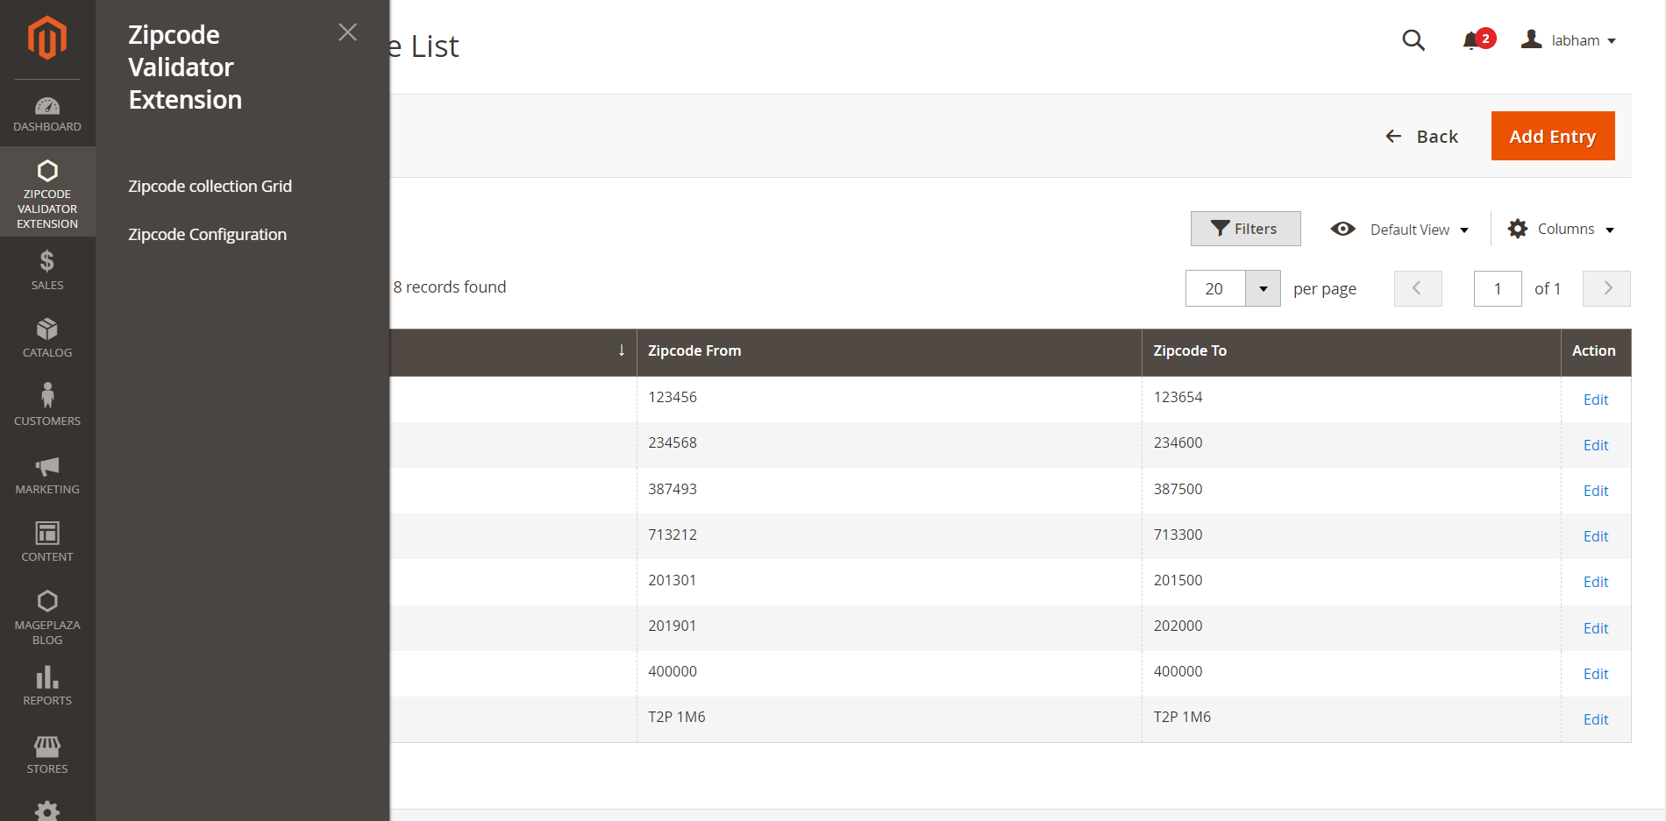

➔ **Zip Code Validator Configuration**

* Enable Zip Code Validator: The admin will select Yes to Enable the module and No to Disable the module.
* Zip Code Validator Availability: The admin will have two options, the first is to Apply to individual products and another is to Apply to all products.

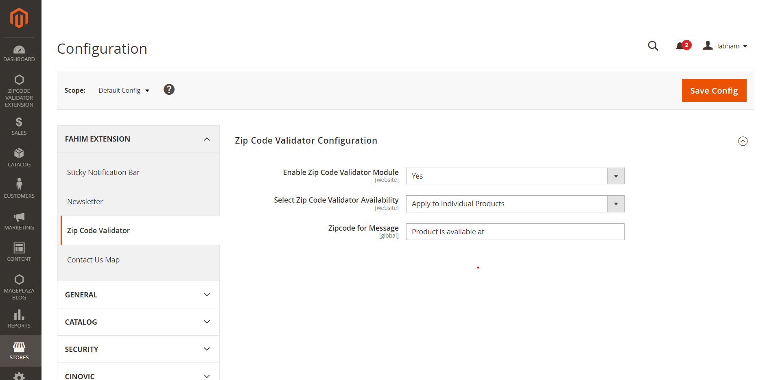

➔ **Zip Code Validator Configuration**

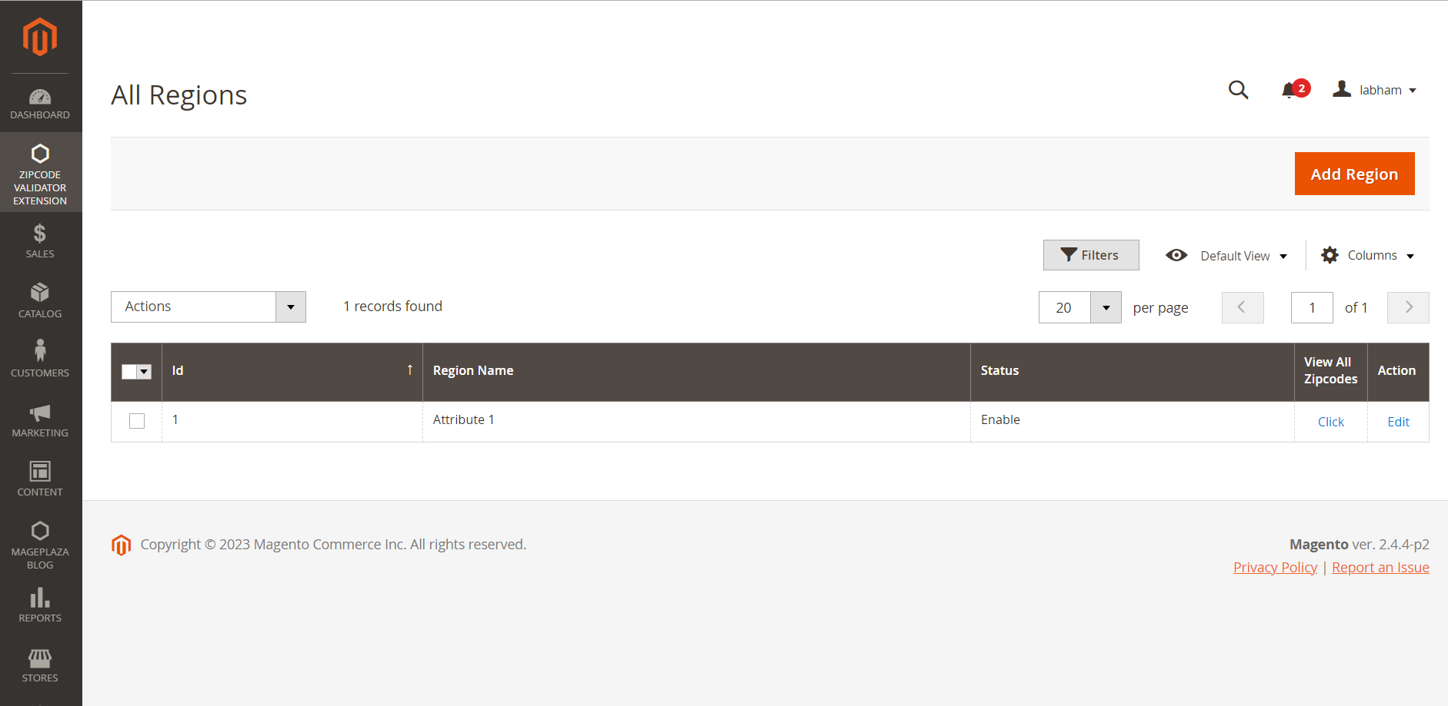

* After this, we will click on View All Zipcodes and we will have to set Pincode as well, we can do that in this grid.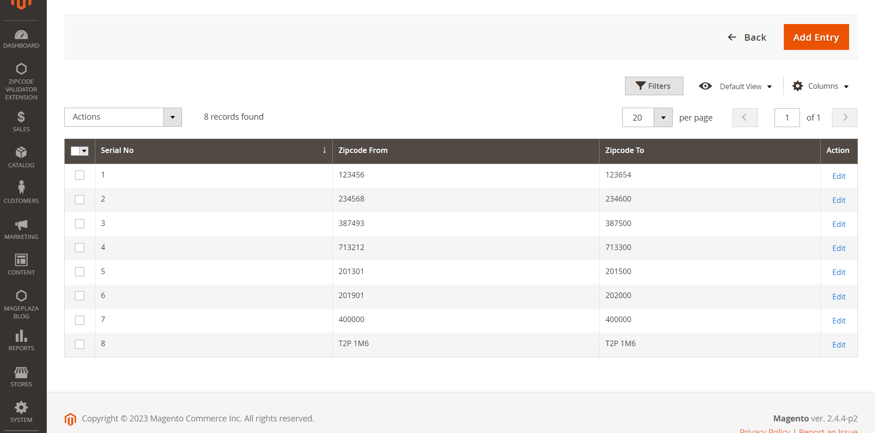

➔  **User Front-End View in Shipping Availability Check**

Firstly, the customer will simply enter the zip code on the product page to find the product availability. After that, the customer will click on the Check Button.

If “Apply to all Products” is selected in the admin configuration then the zip code validator field will be visible on all the products on the storefront.

If “Apply to Individual Products” is selected in the admin configuration and regions are assigned on the particular product page then the zip code validator field will appear on that particular product on the storefront.

And if regions are not assigned to the products in the “Apply to Individual Products” condition in the admin configuration then the zip code validator field will not be visible on the storefront.

If the product is available then the message will appear saying “Product is available at (zip code)”.

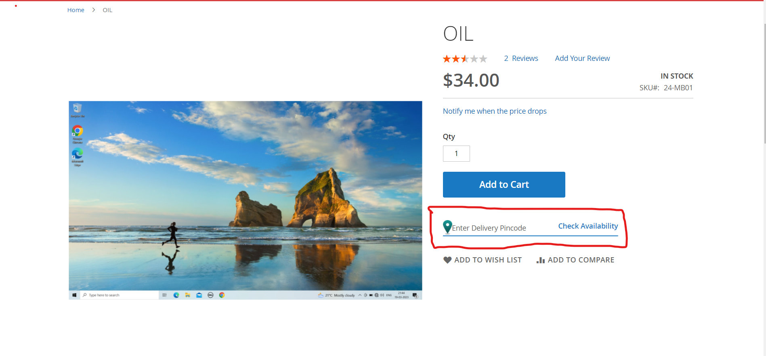

**This type of message for Available Pincode-**

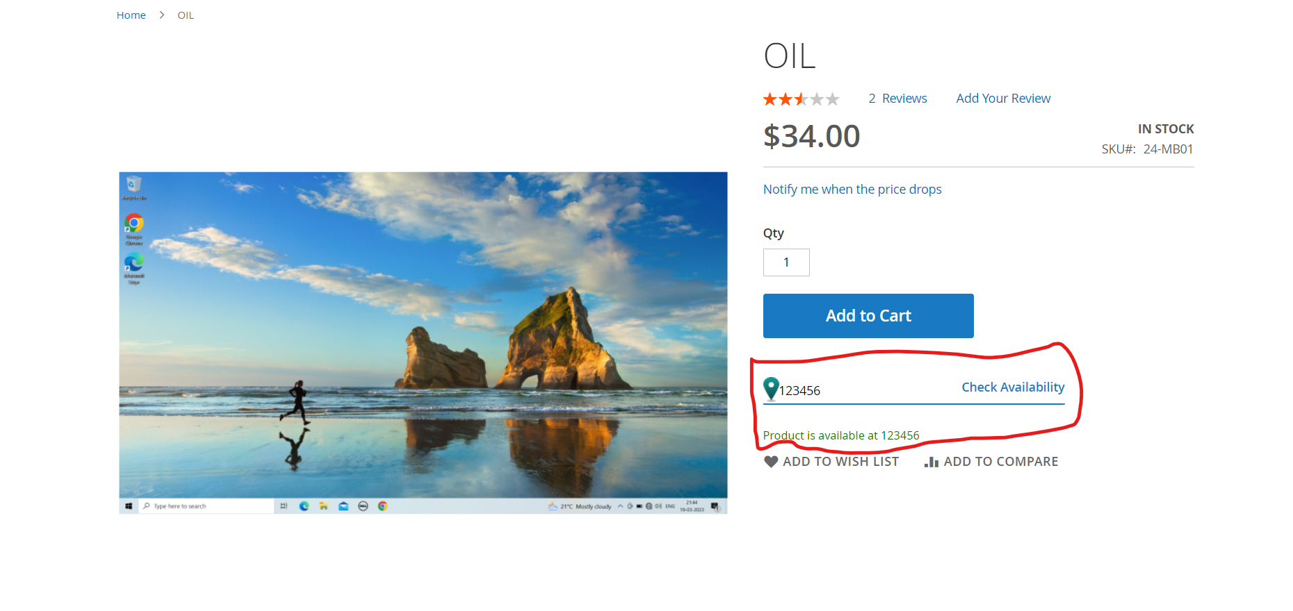

When the searched product is not available then the message will appear saying “Product is not available at (zip code)“.

